  - Work Exercise 57 from Chapter 3. For the load resistors of 7 KΩ use the tolerance levels in the table to perform calculations of ‘Vx’ to fill in the ‘Calculated Vx’ in the table below.
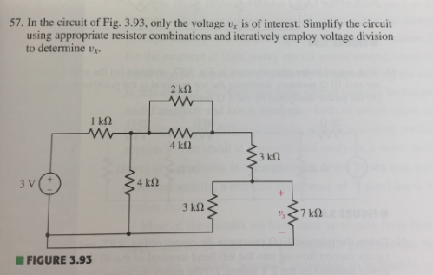

Resistance | Tolerance | Calculated Vx | Measured Vx
7KΩ | -
7KΩ | 0.5%
7KΩ | 1%
7KΩ | 5%

- Construct Figure 3.93 in Multisim.
    - Run simulation to measure the voltage drop across the 7KΩ resistor and record the measurements in the first box under ‘Measured Vx’ column.
    - Now, add the tolerances to the resistor based on the tolerances in the table and run the simulation to complete the table. (Use this document to set up tolerances in Multisim: Setting Up Tolerances in Multisim)
    - Take the screen capture for all the measurements of ‘Vx’.
- Answer the following questions:
    - Does the measured values match the calculated values? If not, explain why they are different?
    - Describe the relationship between the resistance (7KΩ) and measured voltage ‘Vx’?
    - Explain the significance and the effect of adding resistor tolerances on your measurements of ‘Vx’ in Multisim?
- Create a new word document called “Lab1_StudentID.docx” with your GID substituted into the file name.

- Save the analysis from step 2 and simulation results from step 3 along with the table and screen captures of all the measurements. Make sure to answer the questions in step 3.

